 | 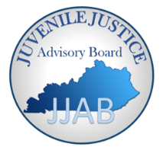
Ida Dickie, Ph.D.  Chairperson | kentucky  JUVENILE JUSTICE ADVISORY BOARD | Eric Hawkins  Vice-Chairperson
JJAB Executive Committee Meeting
Feb 21rst, 2020
1-3:30
Agenda
Agenda Item
- Welcome and Roll Call  - Introduction of New Members: Justin Critteden | Dr. Ida Dickie
- Vote on Minutes from Dec 13th Jan 31rst, 2020
- Vote on Minutes from October 17th- (See Attachment 1)
- Update from Federal Advisory Board Conference Call  - Update about Title II and SAG  - KRS statute change  - Youth Summitt-2016 funds  - Establish executive and Adhoc committees – Youth Summit, Mission, By-Laws and | Dr. Ida Dickie
Title II Application
- Review of Title II application | Marjory Stanek

Day/Date: Feb 21rst, DJJ Large Conference Room 1-3:30. The conference call number is 502-782-2663 or 844-603-5060 and the participant code = 38225. We also have skype capability for state employee computers.
Location: (1025 Capital Center Drive, 3rd Floor, Frankfort) Large conference Room

